**Emerging Methods for Early Detection of Forest Fires**

**A PROJECT REPORT**

**Submitted by**

**TEAM ID: PNT2022TMID39882**

**LOKESH V 511319104043 (Team Leader)**

**LOKESHWARAN S 511319104045**

**SAI DHARUN** **RAJU D 511319104059**

**SIDDIQ ALI S 511319104066**

**YUGANESH P 511319104080**

**CHELLA V 511317104501**

**In partial fulfilment for the award of the degree**

**of**

**BACHELOR OF ENGINEERING**

**in**

**COMPUTER SCIENCE AND ENGINEERING**

**KINGSTON ENGINEERING COLLEGE, VELLORE**

**ANNA UNIVERSITY: CHENNAI 600 025**



**Executed By:**

**IBM**





**TABLE OF CONTENTS**

**1 INTRODUCTION**

1.1 PROJECT OVERVIEW

1.2 PURPOSE

**2 LITERATURE SURVEY**

2.1 EXISTING PROBLEM `

2.2 REFERENCES

2.3 PROBLEM STATEMENT DEFINITION

**3 IDEATION AND PROPOSED SOLUTION**

3.1 EMPATHY MAP CANVAS

3.2 IDEATION& BRAINSTORMING

3.3 PROPOSED SOLUTION

3.4 PROBLEM SOLUTION FIT

**4 REQUIREMENT ANALYSIS**

4.1 FUNCTIONAL REQUIREMENTS

4.2 NON FUNCTIONAL REQUIREMENTS

**5 PROJECT DESIGN**

5.1 DATA FLOW DIAGRAM

5.2 SOLUTION & TECHNICAL ARCHITECTURE

5.3 USER STORIES

**6 PROJECT PLANNING AND SCHEDULING**

6.1 SPRINT PLANNING AND ESTIMATION

6.2 SPRINT DELIVERY SCHEDULE

**7 CODING & SOLUTIONING**

**8 TESTING**

8.1 USER ACCEPTANCE TESTING

8.1.1 DEFECT ANALYSIS

8.1.2 TEST CASE ANALYSIS

**9 RESULTS**

9.1 PERFORMANCE METRIC

**10 ADVANTAGES & DISADVANTAGES**

10.1 ADVANTAGES

10.2 DISADVANTAGES

**11 CONCLUSION**

**12 FUTURE SCOPE**

**APPENDIX**

SOURCE CODE

GITHUB

PROJECT DEMO

**ABSTRACT**

Forests are potentially and seriously threatened by fires which have caused huge damages and losses of life and properties every year. In general, it is easier to detect smoke than fire in its early stage. Developing an effective and safe smoke detection method is thereby critical for early forest fire fighting and preventing the fire developing into uncontrollable. This paper presents a learning-based fuzzy smoke detection approach intended to achieve an effective and early forest fire detection, while greatly reduce the negative impacts from clouds in the sky, illumination variations, and changes of forest features. First, a fuzzy-logic based smoke detection rule is designed for detecting and segmenting smoke regions in the visual images captured by the camera onboard an unmanned aerial vehicle (UAV). The differences of each two components of red, green, and blue (RGB) model and intensity in hue, saturation, and intensity (HSI) model of images are chosen as inputs of a fuzzy logic rule, while the smoke likelihood is selected as its output. Then, an extended Kalman filter (EKF) is further employed for reshaping the inputs and output of the fuzzy smoke detection rule on-line. It is expected to provide the smoke detection method with additional regulating flexibility adapting to variations of environmental conditions and reliable automatic detection performance. Next, the morphological operation is also adopted to remove imperfections induced by noises and textures distorted nonconvex/concave segments. Finally, extensive studies on several sets of images containing smoke under distinct environmental conditions are conducted to validate the proposed methodology.

**CHAPTER 1**

**INTRODUCTION**

* 1. **PROJECT OVERVIEW**

Machine learning and deep learning play an important role in computer technology and artificial intelligence. With the use of deep learning and machine learning, human effort can be reduced in recognizing, learning, predictions and in many more areas.

Forest fire detection is the ability of computer systems to recognise Fire from various region of forest , such as fire, smoke, and so on. This project aims to let users take advantage of machine learning to reduce manual tasks in Detecting the forest fire.

* 1. **PURPOSE**

The main aim of our project is detection and monitoring the forest fire To minimize the effect of fire breakout by controlling in its early stage also to protect Domestic by informing about the breakout to the respective forest department as early as possible . We have implemented the IOT technology to achieve our objective.

**CHAPTER 2**

**LITERATURE SURVEY**

**2.1 EXISTING PROBLEM**

Some of the relevant literary works in this field are briefed below: The one fourth area of Karnataka is covered by forest, the forest and bio-diversity of the India are at the considerable chance and beneath enormous pressure. General causes of forest fire are extreme hot and aired weather, lightning and human carelessness. In order to protect these huge stretches of forest land, there need to be taken early caution measures to control of spreading fire.

**2.2 REFERENCES**

1. **A Review on Early Forest Fire Detection Systems Using Optical Remote Sensing.**

P. Barmpoutis, P. Papaioannou, K. Dimitropoulos, N. Grammalidis

• Environmental Science

• Sensors

• 2020

An overview of the optical remote sensing technologies used in early fire warning systems is presented and an extensive survey on both flame and smoke detection algorithms employed by each technology is provided.

1. **Forest Fire Detection System using LoRa Technology**

N. Gaitan, Paula Hojbota

• Environmental Science

• 2020

This paper proposes a system capable of quickly detecting forest fires on long wide distance using LoRa (Long Range) technology based on LoRaWAN ( Long Range Wide Area Network) protocol which is capable to connect low power devices distributed on large geographical areas.

**3.Low Cost LoRa based Network for Forest Fire Detection**

Roberto Vega-Rodríguez, Sandra Sendra, Jaime Lloret, Pablo Romero-Díaz, José Luis GarcíaNavas

• Computer Science, Environmental Science

• 2019 Sixth International Conference on Internet of Things: Systems, Management and Security (IOTSMS)

2019

A low cost Long Range (LoRa) based network able to evaluate level of fire risk and the presence of a forest fire and the evaluation algorithm is based on the 3030-30 rule.

**4.ASurvey Of Machine Learning Algorithms Based Forest Fires Prediction and detection systems**

F. Abid

• Environmental Science, Computer Science

• Fire Technology

• 2020

A comprehensive survey of the machine learning algorithms based forest fires prediction and detection systems is presented, highlighting the main issues and outcomees within each study.

**2.3 PROBLEM STATEMENT DEFINITION**

Some people know about the current issues are the most important ones because it is mostly a lot in the news but sometimes other big issues that change our lives are not mentioned in the news because they are issues that can hurt us in the long run or not really important for the modern public. One issue I can tell you about is the forest fires. Sometimes people don 't notice or now about the forest fires until it is talk in the news and it 's mostly because it has done a great damage

**CHAPTER 3**

**IDEATION AND PROPOSED SOLUTION**

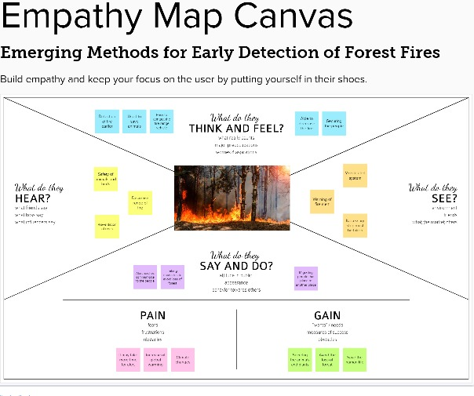

**3.2 IDEATION & BRAINSTORMING**

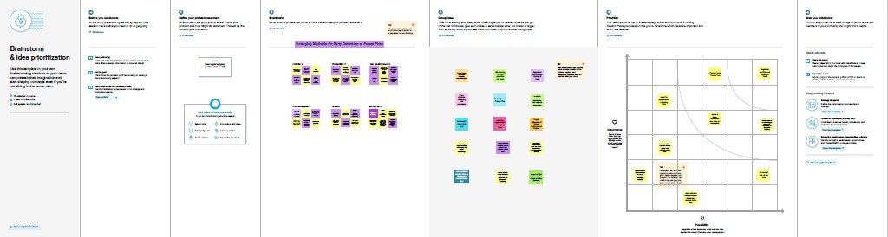

**3.3 PROPOSED SOLUTION**

|  |  |  |
| --- | --- | --- |
| S.No. | Parameter | Description |
| 1 | Problem Statement (Problem to be solved) | This project deals with the problem of The best way out is early detection of forest fire and prevention, To reduce the risk and prevent the forest fire they are big offerings to fight it like planes, fire brigade trucks, also extinguishers to small areas which depends upon the severity of the fire and leads to large investment by concerned agencies.Forest fires are highly destructive and are uncontrollable when it starts spreading over the area. Fire causes respiratory problems for living beings even they are living several kilometers away. The 2019, Australia wildfires almost 15 million acres have been burned and the fire also killed about one billion animals |
| 2 | Idea / Solution description | The key research objectives are as follows: > Forest fires as of late have been annihilating both for normal biological system, biodiversity and woodland economy. >there is an expansion in level of fires that are a significant reason for declining Indian woodlands. >It is about the sensors and dynamic checking framework to dodge a significant fire and genuine harm to woods. |
| 3 | Novelty / Uniqueness | Studies carried out in the present area of investigation depicts that fires help in maintaining the open nature of the barrens by retarding woody plant growth. Fire frequencies determine the overstorey of coniferous composition, besides developing a natural space among the stands. Fire may also play a role in recycling nutrients from the groundlayer vegetation and litter to the overstorey trees, thereby counteracting the infertile substrates and arrested decay . Areas under larger burned patches have higher cover of tree seedlings and shrubs, greater densities of opportunistic species, and lower species richness than smaller patches . The size and shape of a burned area determine in part the number of new habitats that can be used by animals. Animals can invade new habitats and proliferate because they have relatively few contacts with other animals belonging to their own species or other species. |
| 4 | Social Impact / Customer Satisfaction | The results obtained for the NPV, IRR and PP demonstrate that it is possible to think of the forest’s sector in a profitable and sustainable way. However, forestry investors must be aware of the difficulties they will encounter, due the lack of forest investments. |
| 5 | Business Model (Revenue Model) | Forestry economic sector is characterized by small companies, mainly micro-companies, with, on average, 4.1 people per company. Small size of Portuguese private property and the lack of information about its ownership make it difficult to increase the forest sustainability and profitability. In fact, 61% of forest owners have less than 5 ha, corresponding to 26% of the forest area. |
| 6 | Scalability of the Solution | Forest fires lead to destruction of forest wealth and not only that it also destroys the flora and fauna which causes harm to biodiversity. Forest are great resources and to preserve them is a major challenge. As, they are irreparable damage to the ecosystem, so forest fire detection and prevention is utmost important and best way to tackle this problem. But the forest fire early detection and prevention is another major challenge faced all over the world. Several methods for controlling and monitoring of fires have been proposed. In earlier days, manned observation towers were used but this technique was inefficient and failed. After that satellite and camera imaging technologies were tried but this also proved inefficient and ineffective. For example, cameras were installed at different sites in forest but these provide only line of sight pictures. For a very large areas alert system is required as it is really tedious task to monitor all the images. |

**3.4 PROBLEM SOLUTION FIT**

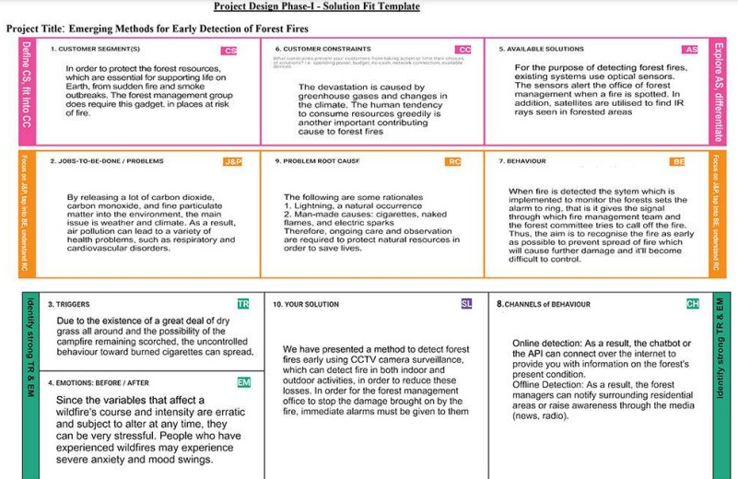

**CHAPTER 4**

**REQUIREMENT ANALYSIS**

**4.1 FUNCTIONAL REQUIREMENTS**

-Following are the functional requirements of the proposed solution

|  |  |  |
| --- | --- | --- |
| **FR No.** | **Functional Requirement (Epic)** | **Sub Requirement (Story / Sub-Task)** |
| FR-1 | User Registration | Registration through G mail |
| FR-2 | User Confirmation | Confirmation via Email Confirmation via OTP |
| FR-3 | User Login | Login using credentials |
| FR-4 | User Search | Search for Info on forest fire occurrence |
| FR-5 | User Profile | User shall be given a live feed of the forest |
| FR-6 | User Application | User is alerted if there is a forest fire occurrence in their surroundings |

**Non-functional Requirements:**

Following are the non-functional requirements of the proposed solution.

|  |  |  |
| --- | --- | --- |
| **FR No** | **Non-Functional Requirement** | **Description** |
| NFR-1 | Usability | Alerts according to the user location |
| NFR-2 | Security | Instant live feed with alert of the situation |
| NFR-3 | Reliability | The prediction of the forest fire is 87% accurate |
| NFR-4 | Performance | The feed and the alert message an immediate action without a lag |
| NFR-5 | Availability | The application gives alerts and live feeds 24/7 |
| NFR-6 | Scalability | Early detection and alerting users are done efficiently and in a faster means |

**CHAPTER 5**

**PROJECT DESIGN**

**Data Flow Diagram**

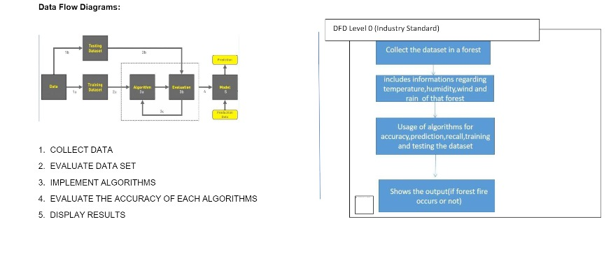

**SOLUTION & TECHNICAL ARCHITECTURE**

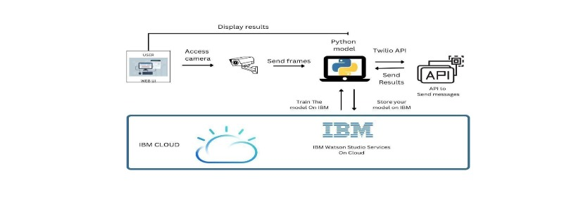

**USER STORIES**

|  |  |  |  |  |  |  |
| --- | --- | --- | --- | --- | --- | --- |
| User type | Functional Requirement (Epic) | User Story Number | User Story / Task | Acceptance criteria | Priority | Release |
| Forest Management Team | Setting up a camera | USN-1 | As a user, the forest management team has to survey the forest by adding camera to the fire prone areas. | The live video captured can be monitored | High | Sprint-1 |
|  |  | USN-2 | As a user, the forest management team can get video feed which is used for processing | The camera sends video or image to the forest centre | High | Sprint-2 |
|  |  | USN-3 | Along with forest team, the NGO can also get access of the video to take some early measurement of forest fires. | They can also get the view of the live monitoring of forest | Low | Sprint-1 |
| Technical Team | Image Classification | USN-4 | By using CNN Model, the images captured by the camera is classified accordingly by testing & training the model | The model should be able to identify the difference between fire and a normal smoke | Medium | Sprint-2 |
|  | Using Open CV | USN-5 | The recorded video is under monitoring continuously to determine the detection of early video | Therefore, by using CNN we can determine the input layer, classify the hidden layers and send warnings through output layer | High | Sprint-2 |
| Alert Team | Dashboard | USN-6 | Thus, after successful detection of fire by processing images. This, API sends the alert by buzzing the alarm and sends messages through chatbot | Thus, the immediate response which is required for earlier determination through sending quick responses | High | Sprint-2 |
| Fire Management | Twilio API | USN-7 | They play the most important role to cool the fire and manage the excess spread of fire further | They take the following measures to  stop fire from spreading | High | Sprint-2 |
| Media & Nearby Residing People | News, Radio, Alerts, | USN-8 | Protecting wildlife, human from the disaster caused | Thus, helping unit should be sent to protect lives | Medium | Sprint-2 |

**CHAPTER 6**

**PROJECT PLANNING AND SCHEDULING**

**6.1 SPRINT PLANNING AND ESTIMATION**

|  |  |  |  |  |  |
| --- | --- | --- | --- | --- | --- |
| **sprint** | **Functional requirement**  **(epic)** | **User Story Number** | **User Story / Task** | **Story Points** | **Priority** |
| Sprint-1 | Import the Required, Collecting the Dataset | USN-1 | To analyse the fire prone areas and to set the surveillance camera to collect and observe the region continuously for early detection. | 2 | High |
| Sprint-2 | To analyse the fire prone areas and to set the surveillance camera to collect and observe the region continuously for early detection. | USN-2 | The collected data are categorized on the basis of parameters set to identify. To train the model, CNN is used to test repeatedly by storing the datasets in server. | 1 | High |
| Sprint-3 | Model Building, Reviewing the model | USN-3 | The main task is to check that the model is efficient to work in real time. Therefore, smallest of error decoded needed to be corrected to avoid future lags | 1 | medium |
| Sprint-4 | Implementing the model | USN-4 | The model after testing all it’s functionalities is been implemented at forest management offices to get quick responses from the model. | 2 | High |
| Sprint-4 | Connecting it with API | USN-5 | The model should connect with API named Twilio, which receives & sends the management with messages. | 2 | High |

**CHAPTER 7**

**CODING & SOLUTIONING**

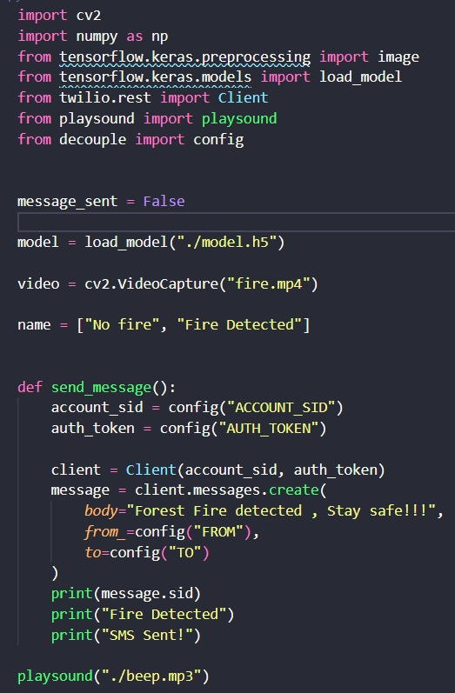

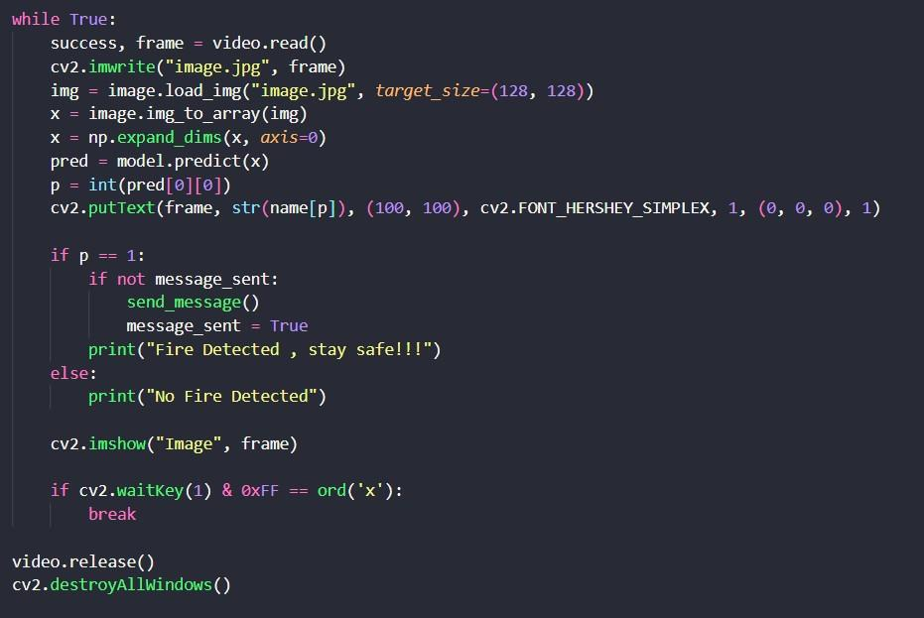

**CHAPTER 8**

**TESTING**

**USER ACCEPTANCE TESTING**

DEFECT ANALYSIS

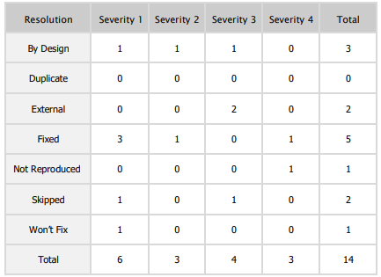

TEST CASE ANALYSIS

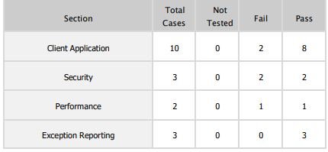

**CHAPTER 9**

**RESULTS**

**PERFORMANCE METRICS**

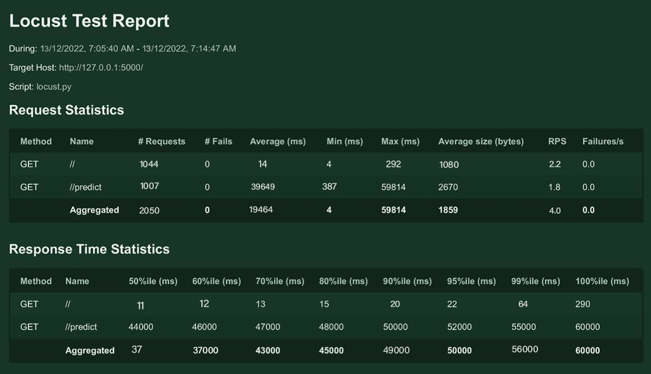

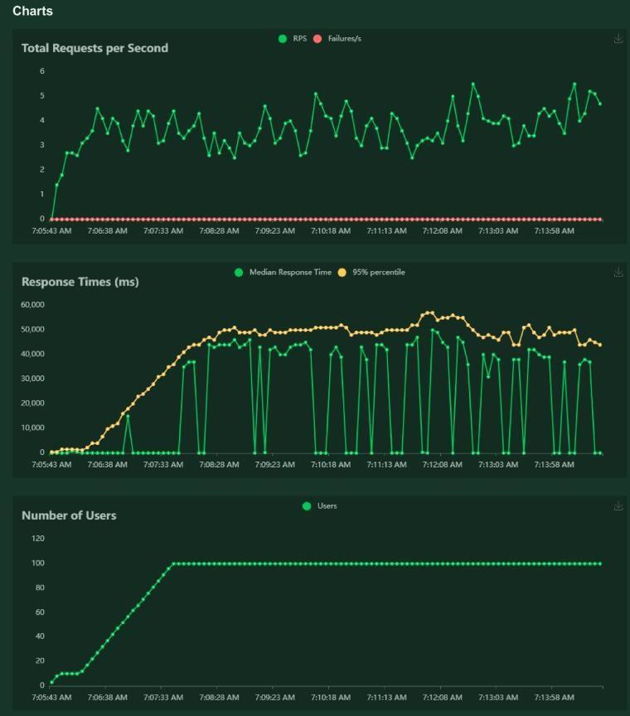

**CHAPTER 10**

**ADVANTAGES & DISADVANTAGES**

**ADVANTAGES**

The proposed system detects the forest fire at a faster rate compared to existing system. It has enhanced data collection feature. The major aspect is that it reduces false alarm and also has accuracy due to various sensors present. It minimizes the human effort as it works automatically. This is very affordable due to which can be easily accessed. The main objective of our project is to receive an alert message through an app to the respective user.

**DISADVANTAGES**

The electrical interference diminishes the effectiveness of radio receiver. The main drawback is that it has less coverage range areas.

**CHAPTER 11**

**CONCLUSION**

This type of system is the first of its kind to ensure no further damage is then to forests when there is fire breakout and immediately a message is sent to the user through the App. Immediate response or early warning to a fire breakout is mostly the only ways to avoid losses and environmental, cultural heritage damages to a great extent. Therefore the most important goals in fire surveillance are quick and reliable detection of fire. It is so much easier to suppressfire while it is in its early stages. Information about progress of fire is highly valuable for managing fire during all its stages. Based on this information the firefighting staff can be guidedon target to block fire before it reaches cultural heritage sites and to suppress it quickly by utilizing required firefighting equipment and vehicles. With further research and innovation, thisproject can be implemented in various forest areas so that we can save our forests and maintaingreat environment.

**CHAPTER 12**

**FUTURE SCOPE**

**This project is far from complete and there is a lot of room for improvement. Some of the improvements that can be made to this project are as follows:**

Additional pump can be added so that it automatically sends water when there is a fire breakout. Also industrial sensors can be used for better ranging and accuracy.

This project has endless potential and can always be enhanced to become better.Implementing this concept in the real world will benefit several industries and reduce the workload on many workers, enhancing overall work efficiency.

**APPENDIX**

**SOURCE CODE**

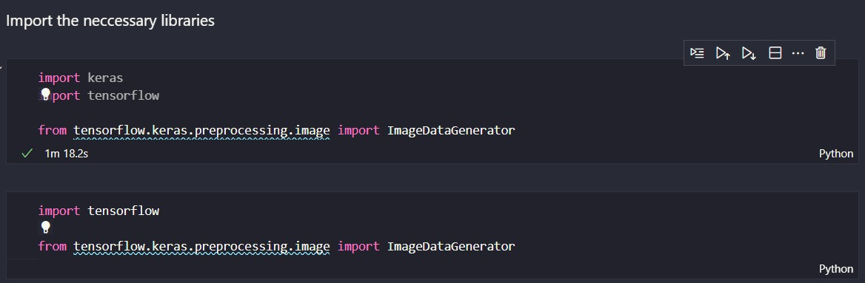

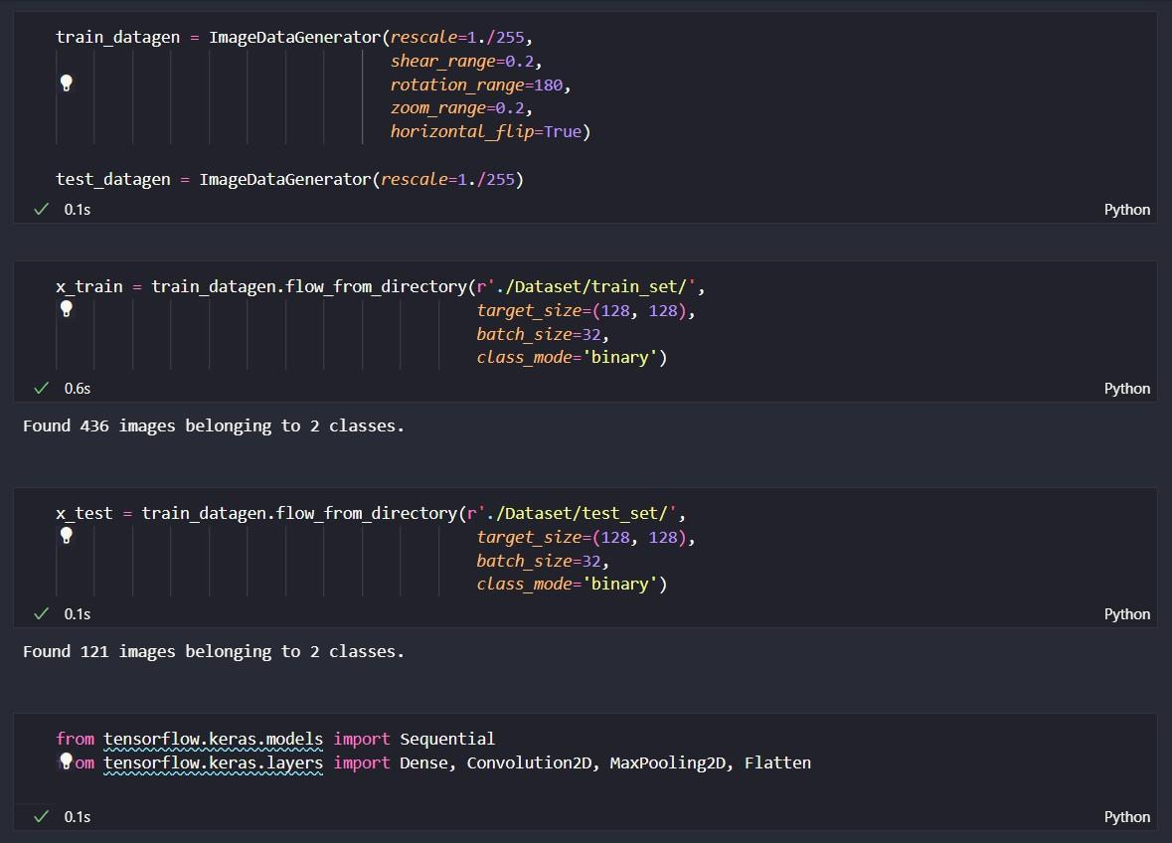

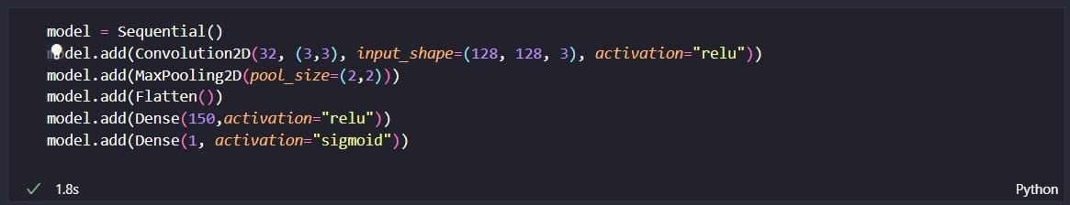

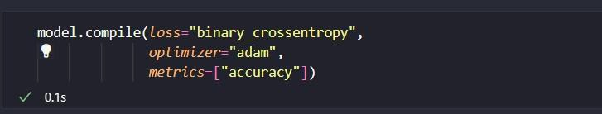

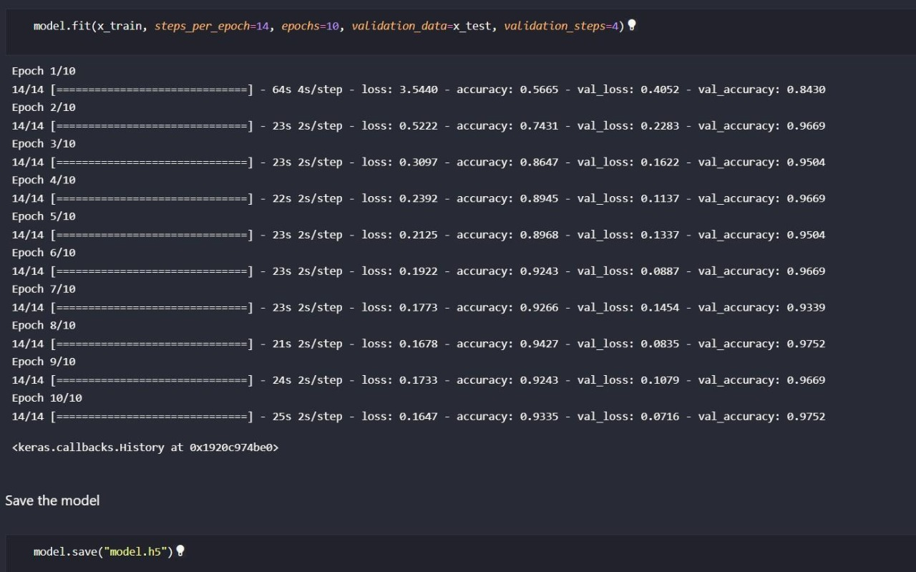

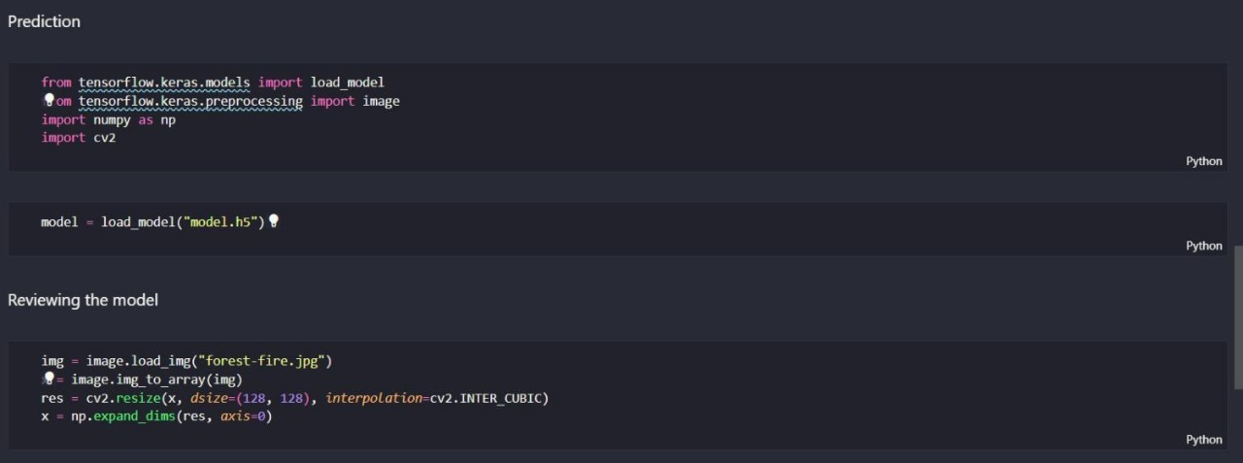

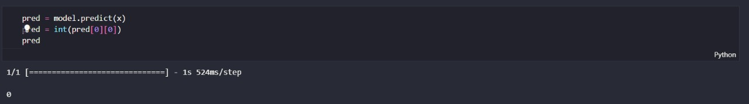

**fire.py**





**GITHUB**

[**https://github.com/IBM-EPBL/IBM-Project-49757-1660838060**](https://github.com/IBM-EPBL/IBM-Project-49757-1660838060)

**PROJECT DEMO**

[**https://drive.google.com/file/d/1wm2DXJumnCxdzvUbBKU8vMiNv1YZMXOv/view?usp=sharing**](https://drive.google.com/file/d/1wm2DXJumnCxdzvUbBKU8vMiNv1YZMXOv/view?usp=sharing)